Suggestions for Hotel Accommodation near Conference Venue (Museumpark 40)
Here are a few suggestions for hotels. You can find many more options through Booking.com.
Please note: prices are subject to change, check the most current prices at time of booking.
For wheelchair accessible hotels in Rotterdam, click here.
For wheelchair accessible hotels with a low sink (in Rotterdam), click here.

2 STAR HOTELS
EasyHotel  Address: Westblaak 67, Rotterdam  Great location, all rooms are simply equipped.  - Distance from conference venue: 500 meters  - Double room €220 for 2 nights, no single rooms  - Can be booked on the above site or on Booking.com  - The hotel is rated with a 6.9 through booking.com |  | 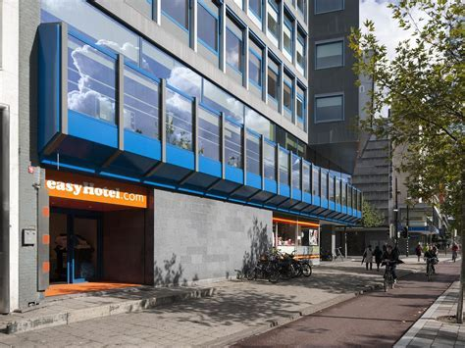
Hotel Baan  Address: Rochussenstraat 345, Rotterdam  Hotel Baan is a comfortable, clean, and pleasant hotel, beautifully situated on the waterfront of Coolhaven, with a view of historic Delfshaven. We offer optimum service for tourists and business travelers. There may also be rooms without a shower/toilet available.  - Distance from conference venue: 700 meters  - Single or double room with shower/toilet,+/- € 220 for 2 nights  - Also possible with shared bathroom  - Breakfast 12.50 per person per day  - Can be booked on the above site or on Booking.com.  - Is rated with an 7.4 on Booking.com  http://www.hotelbaan.nl/ |  | 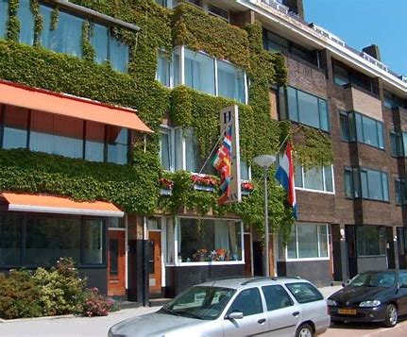
City Hub 2,5 star  Address: Witte de Withstraat 87, Rotterdam  CityHub Rotterdam is an urban hotel for digital natives. A modern take on the old-school youth hostel.  - Distance from conference venue: 1.2 km  - Double room € 188 per 2 nights. Single room € 199 per 2 nights  - Shared bathroom (male/female separately)  - Breakfast for a fee at NRC café (next to the hotel) or €12,- breakfast at the hotel  - Can be booked on the above site or on Booking.com.  - Is rated with an 8.7 through booking.com  https://cityhub.com/rotterdam/ |  | 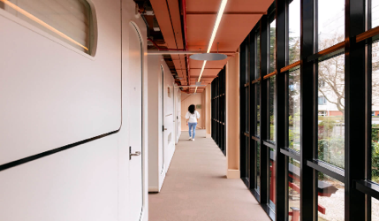
3 STAR HOTELS
Hotel Breitner  Address: Breitnerstraat 23, Rotterdam  Hotel Breitner Rotterdam City Center is a small cozy family hotel in the center of Rotterdam. Our cozy hotel offers you a wonderful place away from home. Our hotel is small but clean, fresh, has a boutique style, a bit old Rotterdam but above all a cozy atmosphere where you will certainly feel at home.  - Distance from conference venue: 950 meters  - Double room € 160 for 2 nights, single room € 120 for 2 nights  - Breakfast possible for a fee  - Can be booked on the above site or on Booking.com.  - Is rated with an 8.2 through booking.com  https://hotelbreitner.nl/ | 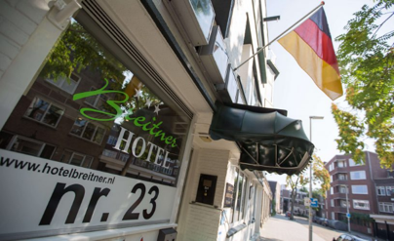
Hotel van Walsum  Address: Mathenesserlaan 199-203, Rotterdam  Hotel Van Walsum is a family-run historic building. It is in a quiet neighborhood. Free Wi-Fi is available throughout the building and private parking is available for a surcharge. The rooms and apartments have a private bathroom and a light interior. The breakfast buffet includes freshly baked bread, bacon, eggs, and various organic and Fair-Trade products. After a busy day you can also unwind on the private garden terrace.  - Distance from conference venue: 650 meters  - Double room € 275 for 2 nights. Single room € 220 for 2 nights  - Breakfast for 15 euro  - Can be booked on the above site or on Booking.com.  - Is rated with an 8.4 on Booking.com  https://www.hotelvanwalsum.nl/nl/home | 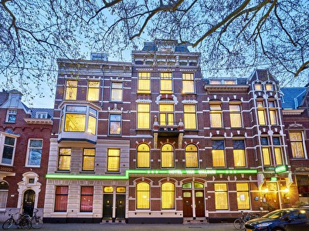

4 STAR HOTELS
Hotel citizenM  Address: Gelderse plein 50, Rotterdam  CitizenM is a Netherlands-based, global hotel developer, investor, and hotel chain. Some of the locations make use of large-scale public art. The public spaces of the hotels feature the "Living Room" furnished with art and furniture from companies such as Vitra, along with artwork and books. The design includes open computer stations where guests check themselves in and out. The Rotterdam hotel has a double ceiling height, a tree, and a wooden staircase in the entrance. The hotels feature automated self-check-in, and do not employ bellhops.  - Distance from conference venue 1,7 km.  - Double room € 469 for 2 nights, breakfast included. Single room: € 440 for 2 nights  - Breakfast included  - Can be booked on the above site or on Booking.com.  - Is rated with an 8.7 on Booking.com  Hotel Rotterdam centrum | Hotel Rotterdam | citizenM | 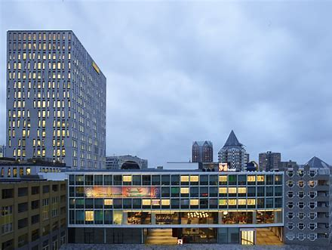
Supernova Hotel  Address: ‘s-Gravendijkwal 68, Rotterdam  Supernova hotel calls itself a non-hotel because it feels more like home than like a hotel. It has 38 rooms with its own characteristics like a balcony, access to the garden, a record player, or a lounge space. Breakfast is a buffet with a selection of high-quality local products.  - Distance from conference venue 600 m  - Double room: € 433. Single room: €401  - Breakfast included  - Can be booked on the above site or on Booking.com.  - Is rated with an 8.8 on Booking.com  Supernova Hotel | 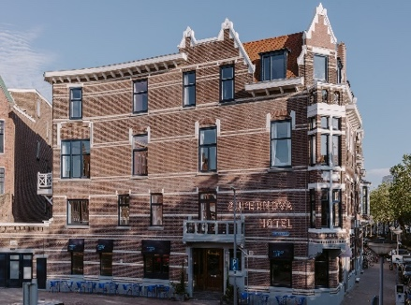

Special and well known **** hotels (with more distance from venue):
Hotel New York Rotterdam  Address: Koninginnenhoofd 1, Rotterdam  Hotel New York is situated in the former headquarters of the Holland-America Line on the 'Kop van Zuid' in Rotterdam. From here, thousands of emigrants left for North America, persuing a better life. Today, people come here to sleep, eat, drink, marry, meet or celebrate. The instant you enter the building, you can feel it; here is where it all happened. The sense of nostalgia is everywhere!  https://hotelnewyork.com | 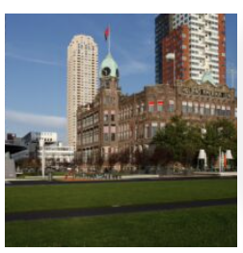
SS Rotterdam  Address: 3e Katendrechtsehoofd 25  As the former flagship of the Holland-America Line, ss Rotterdam has sailed the seven seas. Discover La Grande Dame’s many stories and visit its authentic areas while you eat, drink, sleep, party, meet or work. Today ss Rotterdam is permanently moored in Rotterdam and it's easy to reach.  https://ssrotterdam.com | 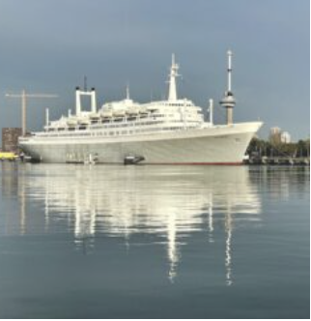
Mainport Design Hotel, 5-star hotel  Address: Leuvehaven 77, Rotterdam  Luxurious and modern hotel, uniquely located on the banks of the River Maas, with breathtaking views of the water and the skyline of Rotterdam.  - Distance from conference venue 1,3 km  - Double room: € 676 for 2 nights. Single room € 636 for 2 nights  - Breakfast included  - Can be booked on the above site or on Booking.com.  - Is rated with an 8.3 on Booking.com  5 Sterren Design Hotel in Rotterdam Centrum - Mainport by Inntel Hotels (mainporthotel.com) | 